**R Code for Examples in the book**

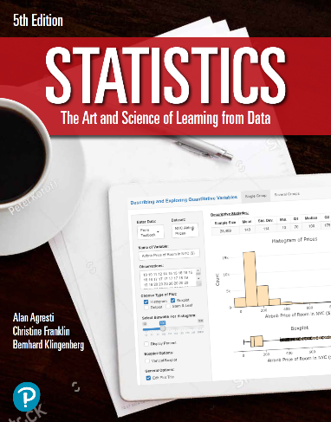

***“Statistics: The Art and Science of Learning from Data”***

**by Agresti, Franklin and Klingenberg, 5th edition**

**Chapter 7**

**Example 5: Average Salary – Sampling Distribution of the Sample Mean**

## Reading in average salary data

mu <- 150  
sigma <- 60  
n <- 32

## To compute standard error or the standard deviation of the sample mean

stdev <- round(sigma / sqrt(n), 1)

## To compute the interval you can expect 95% of the average salaries to fall over many seasons

mu + c(-1, 1) * 2 * stdev

## [1] 128.8 171.2

## To compute the probability that there is a season when his average salary falls below €130, you can use

pnorm(130, mean = 150, sd = 10.6)

## [1] 0.02959412